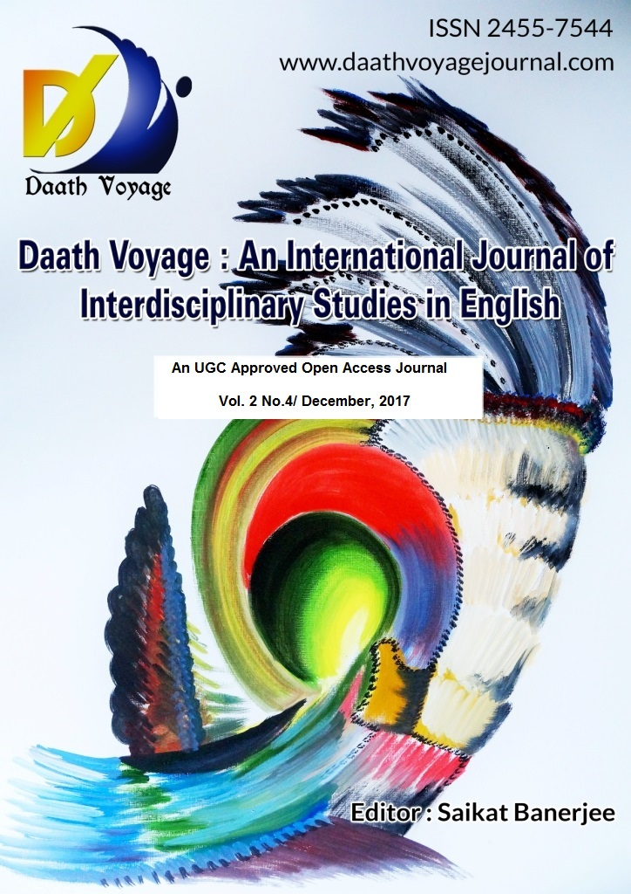

http//:daathvoyagejournal.com

Editor: Dr. Saikat Banerjee Department of English
Dr. K.N. Modi University, Newai, Rajasthan, India.
Conference Report

XIV Annual Conference of Rajasthan Association for Studies in English held at CIT,
Abu Road
Hemendra Chandalia
Professor
JRN Vidyapeeth, Rajasthan.

21st century British Literature echoes futility of warfare
21st Century British Literature echoes futility of warfare as the wars England had participated in as a junior partner of the United States had caused a great human suffering in England too. This was stated in some of the research papers presented at XIV International Conference of Rajasthan Association for Studies in English hosted by Chartered Institute of Technology, Abu Road. In England nationalism is tied to the idea of supporting state policy as we find in India. Many writers in England have raised their voices in favour of global peace, maintaining of ecological balance despite England's participation in allied forces which attacked many countries in the middle east. The two day conference focused on " Contemporary Trends in English Language and Literature: Exploring post 2000 A.D. Writings.
The conference was inaugurated by Prof. N.P. Kaushik, Vice Chancellor, Rajasthan Technical University, Prof. Z.N. Patil, former Professor University of English and Foreign Languages, Hyderabad, Prof. Sumanbala, Delhi University, Sk. Kishore Gandhi, Chairman of Gyan Ratan Trust and Tejas Shah, Director, CIT, Abu Road. Prof. N.P. Kaushik, Chief Guest in his address emphasized the importance of English in enhancing the employability og Engineering and management students. The key note speaker Prof. Suman bala talked about the trends of English literatures across the world and said that English Literature has grown immensely outside England and so Commonwealth Literature and New Literature has assumed greater importance. In her hour long address she underlined the latest trends in British, Indian and commonwealth literature. Professor Hemendra Chandalia, Vice President of Rajasthan Association for Studies in English said that the Association has organized fourteen conferences in fourteen years without a break. He spoke on the theme saying that the ideas of transnationality, hybridity, marginality and diaspora are the trends of late twenties and the first two decades of 21st century literature. He said that 21st century

literature is a literature without established icons. Chairman of UIT, Abu Road Suresh Kothari expressed his best wishes for the conference. Dr. G.K.Sukhwal, Joint Secretary, RASE presented the report of the organization. Mr. Tejas Shah, Director of CIT delivered the welcome address . He said that it was the first time a conference of this scale was being organized at CIT. Mr. Kishore Gandhi also expressed his best wishes for the conference. On this occasion Prof. Z.N. Patil was felicitated for his life time achievements in Language and Language teaching across the globe. Similarly Dr. J.S. Kharagwal was felicitated for his explorations of new settlements at Chandrawati and his contribution to archaeology. A young author, Rithvik Singh Rathore who has penned a novel at the age of fifteen was also felicitated. On this occasion the Journal of Rajasthan Association for Studies in English edited by Dr. Saikat Banerjee was released. He was also felicitated. "Tribal Literature, Culture and Knowledge Systems", a book by Prof. H.S. Chandalia, " Personality Management and Communication " , a book by Dr. Rukhsana Saifee and Dr. Mehzbeen Sadriwala, two books by Dr. G.S. Kushwaha, " Practical Approach to Sociolinguistics" by Dr. H. M. Kothari and Dr. Rekha Ranawat were also released. Dr. J.S. Kharagwal made a power point presentation about the excavation work at Chandrawati. The inaugural was nicely convened by Dr. Anu Badola.
The two day conference was a rich academic feast with three plenary lectures presented by Prof. Z.N. Patil, Professor at Symbiosis, Prof. Nikhilesh Yadav, Professor at Indira Gandhi University Rewari, Haryana and Prof. S. K. Singh , O.P. Jindal University, Raigad, Chhattisgarh. Nine technical sessions were held in which about sixty delegates presented their research papers.

